Access Policy
As Munchkins Kindergarten Ltd is a good quality childcare provision we have premises and policies in places, which makes our nursery accessible for children with additional needs and children with parents on a low income.

The admissions policy is drawn up in an equal opportunities framework. This will be reviewed regularly, kept open and clear to all.

The waiting list will be monitored regularly, reviewing the process and sorting any appeals that may occur.

Munchkins Kindergarten Ltd is registered with Ofsted (EY358868) and this means that many parents/carers who claim the Child Tax Credit can now claim for the additional childcare element within it.

Signed on behalf of the provision by:

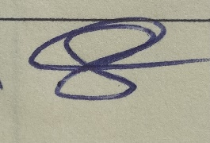
Rachel Beresford
Director

Review date: January 2023

