Access To Information
Parents have the right to see records containing information about themselves or their
children.
All our records contain information that is required by Children’s Services and is kept
confidential.
Any parent/carer wishing to see their child's record books should speak to the manager.
Other information available on request to look at during opening hours is as follows.
• Activity programme
• Fire drill records
• Policies and Procedures
Providing information to Parents/Carers
Information can be passed from staff to parents/caters in many forms:
• Daily diaries
• Through newsletters
• By notices on the notice board
• Informally when the child is collected
• More formally through meetings
• Our online learning journeys via Tapestry
Written Information
Enables parents/carets to:
• Have accurate information
• Understand the reasons why Munchkins operates as it does.
• Become more involved and share responsibility for the care and quality of play.
Munchkins Kindergarten Ltd will always strive to give all parents/carers the same
Information.

Signed on behalf of the provision by:

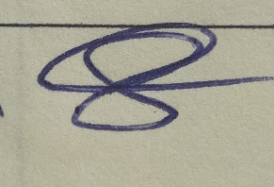
Rachel Beresford
Director

Review Date: January 2023

