Fire Evacuation Policy
Munchkins Kindergarten Ltd will ensure that a clearly written fire drill procedure is on display in all rooms at all times.
- Fire drills will be carried out every term.
- All visitors to the setting will be informed of the settings fire drill procedures and building evacuation process.
- The fire drill procedure will be displayed in the setting at all times.
- Each fire drill will be recorded in a log, be reviewed and evaluated.
- All new members of staff/volunteers/students will receive a fire drill information sheet and fire training within the first week of employment as part of their staff induction.
- All fire exit doors and firefighting equipment will be kept free of obstructions and clearly located with the appropriate signage.
- Daily risk assessment checks will ensure all exits are free from obstruction and are fully operational.
- A fire risk assessment will be conducted and reviewed regularly.
- All electrical equipment will be regularly checked to ensure they are in safe working order and PAT testing will be carried out annually.
- Any recommendations made by the Fire Prevention Officer will be carried out and adhered to.
- Smoke detectors/alarms will be checked weekly and fire fighting equipment will be checked annually or according to the fire officers recommendations and the date of those checks will be recorded.
- The premises and surrounding area operates a strict no smoking policy.
- The fire evacuation procedure will be explained to all visitors to ensure their safety whilst on the premises.
- All visitors will be required to sign in and out of the setting in designated visitor’s record; this record will be used as part of the evacuation procedure to ensure all persons are accounted for.
- A clear daily record of staff and children on the premises will be maintained (including arrival and departure times); this record will be used as part of the evacuation procedure to ensure all persons are accounted for.

This policy has been adopted by Munchkins Kindergarten Ltd
Signed on behalf of the setting by:
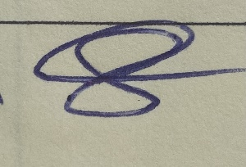

Rachel Beresford, Owner
Review Date: January 2023

