Health Policy
It is the aim of Munchkins Kindergarten Ltd to promote a healthy environment for the children and therefore we need your cooperation to achieve this.
Children will have the opportunity to play in the fresh air all year round.

Any child suffering from the following:
A doubtful rash, discharge from the eyes, diarrhoea, vomiting or a fever of 101f / 38c should
be kept at home until a doctor has confirmed that the symptoms are clear.

If a child becomes unwell at the setting, every effort will be made to contact the parents/carers. lt is essential therefore that the Nursery has the up to date information in order to be able to contact the parents/carers during Nursery hours.

Munchkins Kindergarten Ltd reserves the right to take the child to hospital in an emergency, and in the event of parents/carers not being available (this will be authorised by parents/carers when signing permission slips).

Munchkins Kindergarten Ltd will maintain links with health visitors in order to gather information and advice from the local authority/children's services or other health agencies.

Advice and guidance can be obtained from the public health team.
Signed on behalf of the setting by:
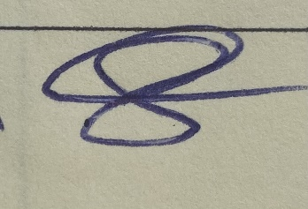
Rachel Beresford, Owner
Review date: January 2023

