Play and Equipment Policy
• All toys and equipment used by Munchkins Kindergarten ltd will be safe, hygienically
cleaned and checked at regular intervals.
• Toys and equipment will be available to stimulate all ages and abilities, regardless of
gender.
• A wide and varied selection of activities will be available and staff will adapt any activity
to the child's needs.
• Each child will be able to decide upon their own choice of play.
• All toys and equipment will be sturdy and well made. They will be constructed from non
toxic materials.
• Play plans will be in operation, and will be regularly reviewed, with input from the
children.
• The equipment we provide will promote positive images of people, both male and
female, from a wide range of ethnic and cultural groups, with and without special needs.
• Each child will be provided with the opportunity to experience a varied programme of
activities, which include a balance of active and quiet play.
• Outdoor play will be treated as importantly as indoor play.
• Old equipment will be discarded when needed and replaced with new once the budget
has been agreed.

Signed on behalf of the setting by:

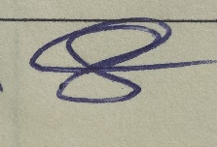

Owner

Review date: April 2024

