Visitor Policy
Munchkins Kindergarten Ltd will ensure that names of all visitors on site are recorded for emergency, insurance and registration purposes.
- All visitors are valued for whatever reason, but the children are our priority and must come first.
- All visitors will be welcomed and their enquiries dealt with as soon as possible.
- Children and parents are welcome to visit us prior to joining the setting.
- No visitor will be left alone with children or accompany children to the toilet.
- Whenever possible visitors should make an appointment to visit the setting.
- Visitors will be requested to sign in and out of the premises, giving their reason for the visit.
- The fire evacuation procedure and confidentiality policy will be explained to all visitors upon entry to the premises.

If a visitor calls unannounced;
- Ask for identification, who they wish to see and request the purpose of their visit.
- Show them to a comfortable area, where they can wait until someone is free to speak to them.
- Explain that the setting is busy and they may have to wait until a staff member is free to deal with them. Give the option of waiting or making an appointment.
- In all cases, ensure that the visitor’s book has been signed and procedures explained.

NB: The setting/staff have the right to refuse entry to an individual if they are uncertain as to the purpose of their visit.
This policy has been adopted by Munchkins Kindergarten Ltd
Signed on behalf of the setting by:
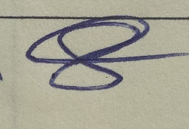
Owner

Review Date: April 2024

