Suggestions and Concerns

Any suggestions or concerns that a parent/carer may have about Munchkins Kindergarten Ltd will be welcomed and encouraged.

It should be raised with the Manager who will act on it accordingly.

All suggestions and concerns will be taken seriously, and positively.

Anyone with a complaint about the provision should refer to Munchkins Kindergarten Ltd’s complaints policy.

Signed on behalf of the setting by:

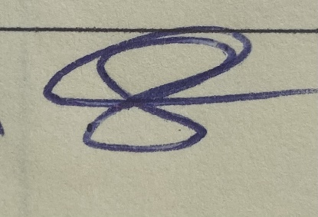

Review date: April 2025

